Holy Week at Home family retreat

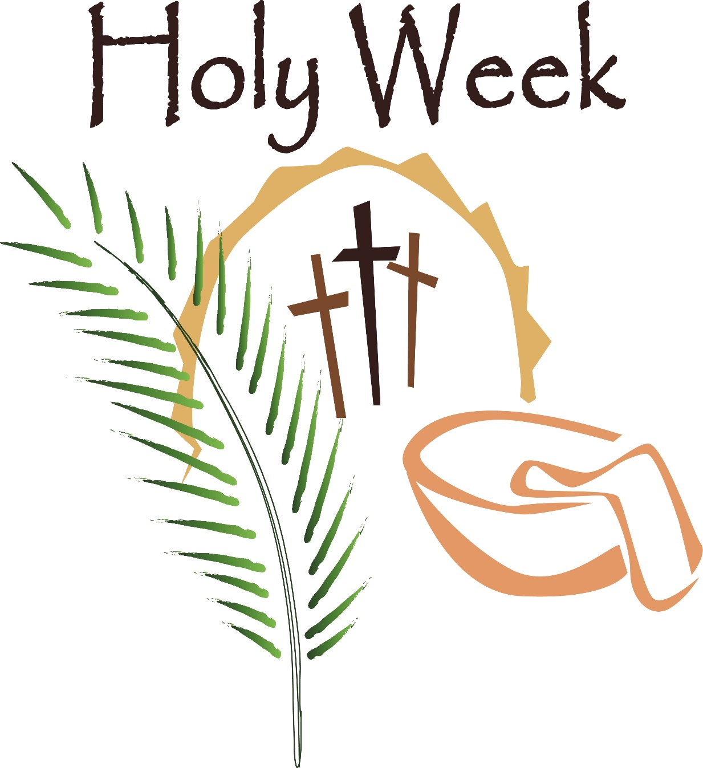

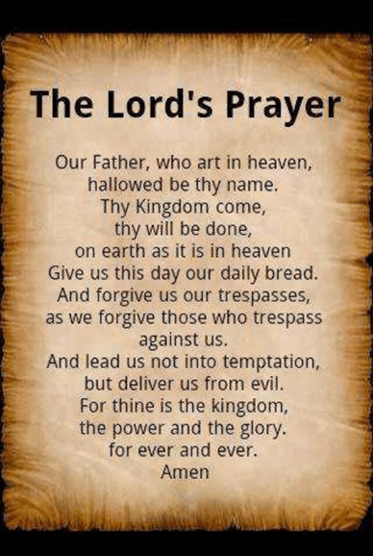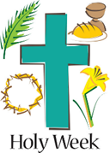Holy Week 2020 is being celebrated amid extraordinary circumstances. It is important to follow the advice to stay at home in order to protect ourselves and each other from being infected with the Covid-19 virus. Therefore, as a way to observe Holy Week at home, we invite you and your family to enter into a Holy Week retreat using this booklet. On the next few pages, you will find Scripture verses, prayers and activities to help worship at home as a family.

WHAT IS Holy Week?

**PALM SUNDAY: JESUS RIDES INTO JERUSALEM**

Jesus rides into Jerusalem on a donkey. He is greeted by crowds waving palm leaves and shouting ‘Hosanna!’



**WEDNESDAY OF HOLY WEEK: THE SERVANT KING**

Jesus is the Servant King. During Holy Week, he washes the feet of the disciples, taking on the role of servant and teaching his followers how to serve others.

**TUESDAY OF HOLY WEEK: THE BETRAYAL**

Jesus predicts that he will be betrayed and another of his disciples will deny him three times.

**MONDAY OF HOLY WEEK: MARY’S GIFT TO JESUS**

Mary anoints the feet of Jesus with expensive oil.

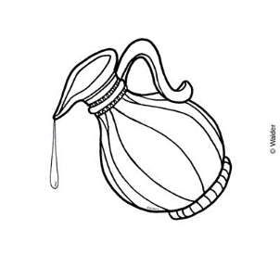



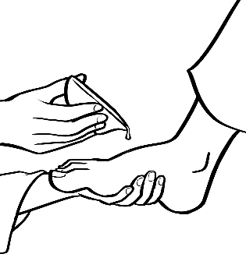

WHAT IS Holy Week?



**MAUNDY THURSDAY: THE LAST SUPPER**

Jesus blesses the bread and wine and shares it with his disciples.

**EASTER SUNDAY: HE IS RISEN!**

Alleluia! Alleluia!

Jesus is Risen!

**GOOD FRIDAY: JESUS IS CRUCIFIED AND DIES ON THE CROSS**

Jesus carries the heavy cross through the streets of Jerusalem to a place called Golgotha. Here, he is nailed to the cross and dies.



**HOLY SATURDAY: THE DAY OF WAITNG**

For the first disciples, this was a day of mourning. Their friend and teacher had been killed and was now in the tomb. For us today, it is a day of hopeful waiting, knowing this is not the end of the story.



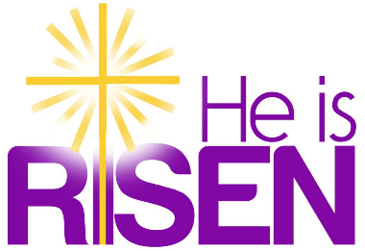

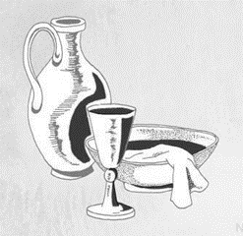MAUNDY THURSDAY

**9th April 2020**

*Become silent, aware of the awesome presence of God who never ceases to be with us.*

**In the name of the Father, and of the Son, and of the Holy Spirit. Amen.**

**Glory be to the Father, and to the Son, and to the Holy Spirit, as it was in the beginning, is now and ever shall be, world without end. Amen.**

**Here I am, Lord, I come to do your will.**

Prayer for the day

Loving Provider, you gather me to yourself to be fed by your love. At the Last Supper, Jesus told us to "love one another" and I know that is the heart of his gift, his sacrifice for me. I ask that I might find the source of my own heart, the meaning for my own life, in that Eucharist. Guide me to the fullness of your love and life. Amen.

*We know that you are with us, Lord. You never leave us or abandon us in our need. I now open my ears and my heart to listen to your Word through the Holy Gospel. (Matthew 26:26-29)*

**While they were eating, Jesus took a loaf of bread, and after blessing it he broke it, gave it to the disciples, and said, “Take, eat; this is my body.” Then he took a cup, and after giving thanks he gave it to them, saying, “Drink from it, all of you; for this is my blood of the covenant, which is poured out for many for the forgiveness of sins. I tell you, I will never again drink of this fruit of the vine until that day when I drink it new with you in my Father’s kingdom.”**

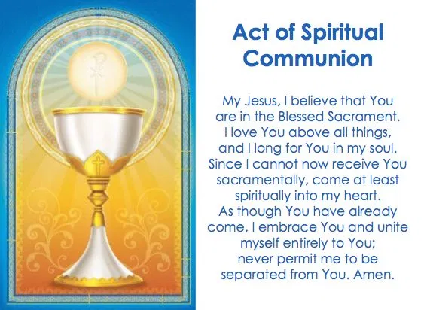

Final Prayer

Lord God, grant that, just as we are renewed by the Supper of your Son in this present age, so we may enjoy his banquet for all eternity. We ask this through Christ our Lord. Amen.

*In the name of the Father, and of the Son, and of the Holy Spirit. Amen.*

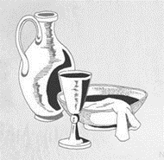 MAUNDY THURSDAY

**Have a chat/make a note…**

* **How many times have you been to church and received Holy Communion?**
* **Did you know the Holy Communion was directly linked to the Last Supper?**
* **After reading the piece of scripture, do you think this is something that Jesus wants us to participate in often?**



The Last Supper (Miracle Maker)

<https://m.youtube.com/watch?v=UaiYNF5uchA&t=8s>

Be Still hymn

<https://m.youtube.com/watch?v=ZugvUQ4m90U>

**The Last Supper was a Jewish Passover meal. The story of the first Passover is seen in the Book of Exodus in the Bible. Watch the film the Prince of Egypt which tells this story.**

**Join in with Evening Prayer with Llangyfelach Church. Contact Fr Anthony Porter for further details.**



**Spend some time in quiet today reflecting on the Act of Spiritual Communion. Write down your thoughts.**

**During the Last Supper, Jesus asked his followers to ‘Love one another’. Make a list of how you can show love to others.**

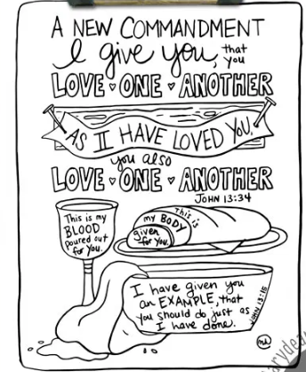

GOOD FRIDAY

**10th April 2020**

*Become silent, aware of the awesome presence of God who never ceases to be with us.*

**In the name of the Father, and of the Son, and of the Holy Spirit. Amen.**

**Glory be to the Father, and to the Son, and to the Holy Spirit, as it was in the beginning, is now and ever shall be, world without end. Amen.**

**Here I am, Lord, I come to do your will.**

Prayer for the day

Lord of Glory, we proclaim your death and look ever forward to your Resurrection. As we contemplate your Cross, where you died so that we may have life, may we be ever aware of the life that springs from death, the light that rises from darkness, and the hope that banishes fear. Draw us close to you, so that we may know your glory. We ask this through Christ, our Lord. Amen.

*We know that you are with us, Lord. You never leave us or abandon us in our need. I now open my ears and my heart to listen to your Word through the Holy Gospel. (Matthew 27:45-51)*

**From noon on, darkness came over the whole land until three in the afternoon. And about three o’clock Jesus cried with a loud voice, “Eli, Eli, lama sabachthani?” that is, “My God, my God, why have you forsaken me?” When some of the bystanders heard it, they said, “This man is calling for Elijah.” At once one of them ran and got a sponge, filled it with sour wine, put it on a stick, and gave it to him to drink. But the others said, “Wait, let us see whether Elijah will come to save him.” Then Jesus cried again with a loud voice and breathed his last. At that moment the curtain of the temple was torn in two, from top to bottom. The earth shook, and the rocks were split.**



Final Prayer

Lord God, may your abundant blessing descend upon your people; those who have honoured the death of your Son in the hope of the resurrection: may pardon come, comfort be given, holy faith increase, and everlasting redemption be made secure. Amen.

*In the name of the Father, and of the Son, and of the Holy Spirit. Amen.*

 GOOD FRIDAY

**Have a chat/make a note…**

* **Imagine you are one of Jesus' first disciples how would you feel if you were there?**
* **What is so good about Good Friday? Why do we call it Good Friday if Jesus died on that day?**



The Crucifixion of Jesus (Miracle Maker)

<https://m.youtube.com/watch?v=88vJ5A_oLRM>

Holy Week in 3 minutes (Busted Halo)

<https://m.youtube.com/watch?v=qdrPhxqRP9I>

Taize: Jesus Remember Me

<https://www.youtube.com/watch?v=uzTo-8pusSQ>

**Make a Cross out of things in your house. You could use toys or Lego, or sticks from the garden.**

**Join in with Evening Prayer with Llangyfelach Church. Contact Fr Anthony Porter for further details.**



**Jesus died on the cross to save us from our sins. Make a paper cross and on the cross, write some things that you have done wrong and are sorry for.**

**Pray the Stations of the Cross together.**

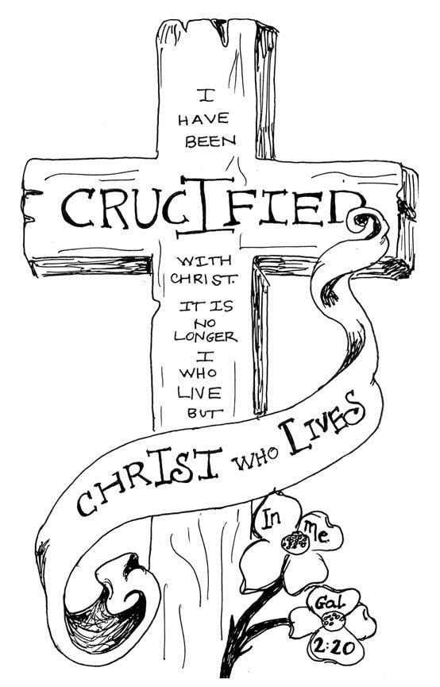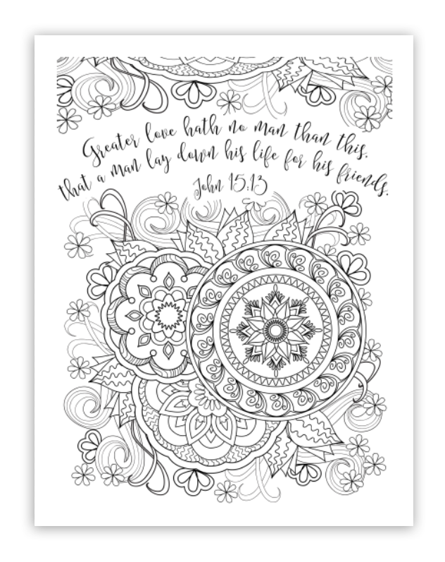

HOLY SATURDAY

**11th April 2020**

*Become silent, aware of the awesome presence of God who never ceases to be with us.*

**In the name of the Father, and of the Son, and of the Holy Spirit. Amen.**

**Glory be to the Father, and to the Son, and to the Holy Spirit, as it was in the beginning, is now and ever shall be, world without end. Amen.**

**Here I am, Lord, I come to do your will.**

Prayer for the day

Lord God, on the Sabbath, Jesus rested. He was in the grave. He had finished His work. To most people’s eyes, it looked as if it were all over. He was dead and buried. But only as a seed dies when it is planted in the earth, not to decay, but to spring to new life. Teach us to hope always in you and in the resurrection, the making of all things new. Amen.

*We know that you are with us, Lord. You never leave us or abandon us in our need. I now open my ears and my heart to listen to your Word through the Holy Gospel. (Based on Psalm 29/20: 1, 3-5, 10-12)*

**I will praise you, Lord, because you have saved me. You have rescued my soul from death and given me back my life. I will sing songs of thanks to the Lord, and show the depth of my love for him. His goodness lasts forever. He wipes away my tears, and fills my life with happiness. The Lord is merciful and comes to my aid. He changes my sadness into joy and I will give thanks for ever to the Lord my God.**



Final Prayer

Almighty, ever-loving God, whose only Son descended to the realm of the dead, and rose from there to glory, grant that your faithful people, may, by his resurrection, obtain eternal life. Amen.

*In the name of the Father, and of the Son, and of the Holy Spirit. Amen.*

 HOLY SATURDAY

**Have a chat/make a note…**

* **What must it have been like? Jesus, who you love and trust, who said He would rise, who you believe is the Messiah is now dead and in the tomb.**
* **Saturday is a day of waiting in hope. Are we living our lives with this same hope? Do we really believe that Jesus rose and is now in heaven? Are we living a life that reflects that hope?**



Easter - It's Saturday But Sunday's Coming (K-Love) <https://m.youtube.com/watch?v=PVAaI1MpotE>

Taize: O Lord, hear my prayer

<https://m.youtube.com/watch?v=z-2WZFf_uAc>

**Today is a day of waiting. Place a clock in your prayer space.**

**Join in with Evening Prayer with Llangyfelach Church. Contact Fr Anthony Porter for further details.**



**Make a colourful cross that you can put in your window before you go to sleep so that in the morning others will see and know that Jesus is Risen.**

**Today is traditionally a quiet day. See if you can set some times for silence, where no one is allowed to speak.**

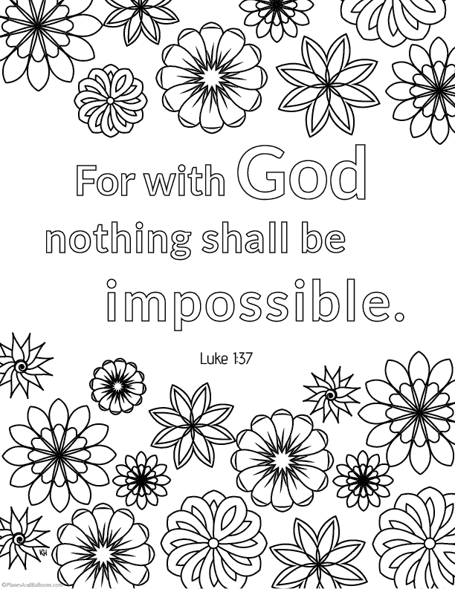

EASTER SUNDAY

**12th April 2020**

*Become silent, aware of the awesome presence of God who never ceases to be with us.*

**In the name of the Father, and of the Son, and of the Holy Spirit. Amen.**

**Glory be to the Father, and to the Son, and to the Holy Spirit, as it was in the beginning, is now and ever shall be, world without end. Amen.**

**Here I am, Lord, I come to do your will.**

Prayer for the day

Lord God, you loved this world so much, you gave your one and only Son, that we might be called your children too. Lord, help us to live in the gladness and grace of Easter Sunday, every day. Let us have hearts of thankfulness for your sacrifice. Let us have eyes that look upon Your grace and rejoice in our salvation. Help us to walk in that mighty grace and tell your good news to the world. Amen.

*We know that you are with us, Lord. You never leave us or abandon us in our need. I now open my ears and my heart to listen to your Word through the Holy Gospel. (John 20:1-9)*

**On Sunday morning while it was still dark, Mary Magdalene went to the tomb and saw that the stone had been rolled away from the entrance. She ran to Simon Peter and to Jesus' favourite disciple and said, “They have taken the Lord from the tomb! We don’t know where they have put him.” Peter and the other disciple started for the tomb. They ran side by side, until the other disciple ran faster than Peter and got there first. He bent over and saw the strips of linen cloth lying inside the tomb, but he did not go in. When Simon Peter got there, he went into the tomb and saw the strips of cloth. He also saw the piece of cloth that had been used to cover Jesus' face. It was rolled up and in a place by itself. The disciple who got there first then went into the tomb, and when he saw it, he believed. At that time Peter and the other disciple did not know that the Scriptures said Jesus would rise to life.**



Final Prayer

Almighty, ever-loving God, look upon your Church with unfailing love and favour. Renewed by the Paschal Mysteries, may we come to the glory of the Resurrection. We ask this through Christ our Lord. Amen.

*In the name of the Father, and of the Son, and of the Holy Spirit. Amen.*

 EASTER SUNDAY

**Have a chat/make a note…**

* **The tomb was empty. Why is the concept of something being empty usually considered a bad thing?**
* **It might feel at the moment that we are doing a lot of waiting during this time in isolation. Easter teaches us to wait in hope. Is there anything you have learnt during this time so far that you would like to continue with once we are back into our normal routine of life?**



The Empty Tomb – Miracle Maker

<https://m.youtube.com/watch?v=fa5VhwkSx_o>

The Christian Story of Easter

<https://m.youtube.com/watch?v=Wnbo2AmS3OI>

Alleluia, Alleluia! Give thanks to the Risen Lord

<https://m.youtube.com/watch?v=2U1MuOCHon4>

Matt Redman – The Heart of Worship

<https://m.youtube.com/watch?v=OD4tB1o6YLw>

**Watch the sunrise and thank God for giving us His Son to show us how to be wonderful people.**

**Participate in an Easter service via a live stream.**



**Set up an Easter egg hunt or make Happy Easter cards for your neighbours.**

**Make banners celebrating Jesus rising from the dead. Use words like "Alleluia!" "He is alive!" "He is risen!" "Happy Easter!" "Christ lives!"**

